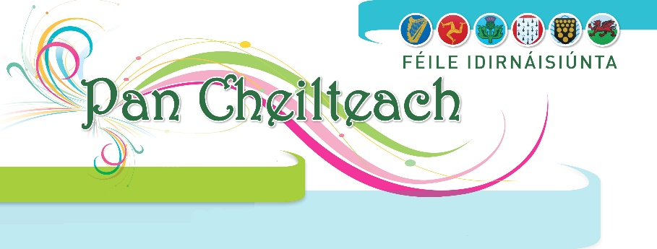

**Competition Entry Form 2025**

**Celtic Nation**

**Competition Number**

**Competition Title**

**Competitor Name**

**Address**

**Email**

**Phone / Mobile**

**Date of Birth***(For Junior competitors)*

**For Choral Competitions only**

**Conductor**

**Number in Choir**

**New Entrant (Please Tick Yes or No) Yes No**

**Song 1: Title**

**Duration (No. of Minutes)**

**Song 2: Title**

**Duration (No. of Minutes)**

**For Solo & Group Traditional Singing Competitions only**

**Song 1: Title**

**Duration (No. of Minutes)**

**Song 2: Title**

**Duration (No. of Minutes)**

**If Song 1 or Song 2 is a new composition, please state.**

*Performers must provide a stage Plan and list of instruments stating whether electric or acoustic. If performing a of new composition, words with translation and music must be submitted with entry.*

**For National Committee Secretary only**

**I confirm that competitors understand that by filling out this form they give consent to the Pan Celtic committee to contact them regarding the festival in 2025 and that their details (name, address, email, phone number and date of birth for junior entrants) will be stored to simplify the administration process.**

**I confirm that the competitors have read and understood the rules of this competition and have agreed to their terms.**

**Fee**

**Signature**

**Date**